AI LAB1(CAMEL-BANANA PROBLEM)

CODE:

total=int(input('Enter no. of bananas at starting'))

distance=int(input('Enter distance you want to cover'))

load_capacity=int(input('Enter max load capacity of your camel'))

lose=0

start=total

for i in range(distance):

while start>0:

start=start-load_capacity

if start==1:

lose=lose-1

lose=lose+2

lose=lose-1

start=total-lose

if start==0:

break

print(start)

OUTPUT:

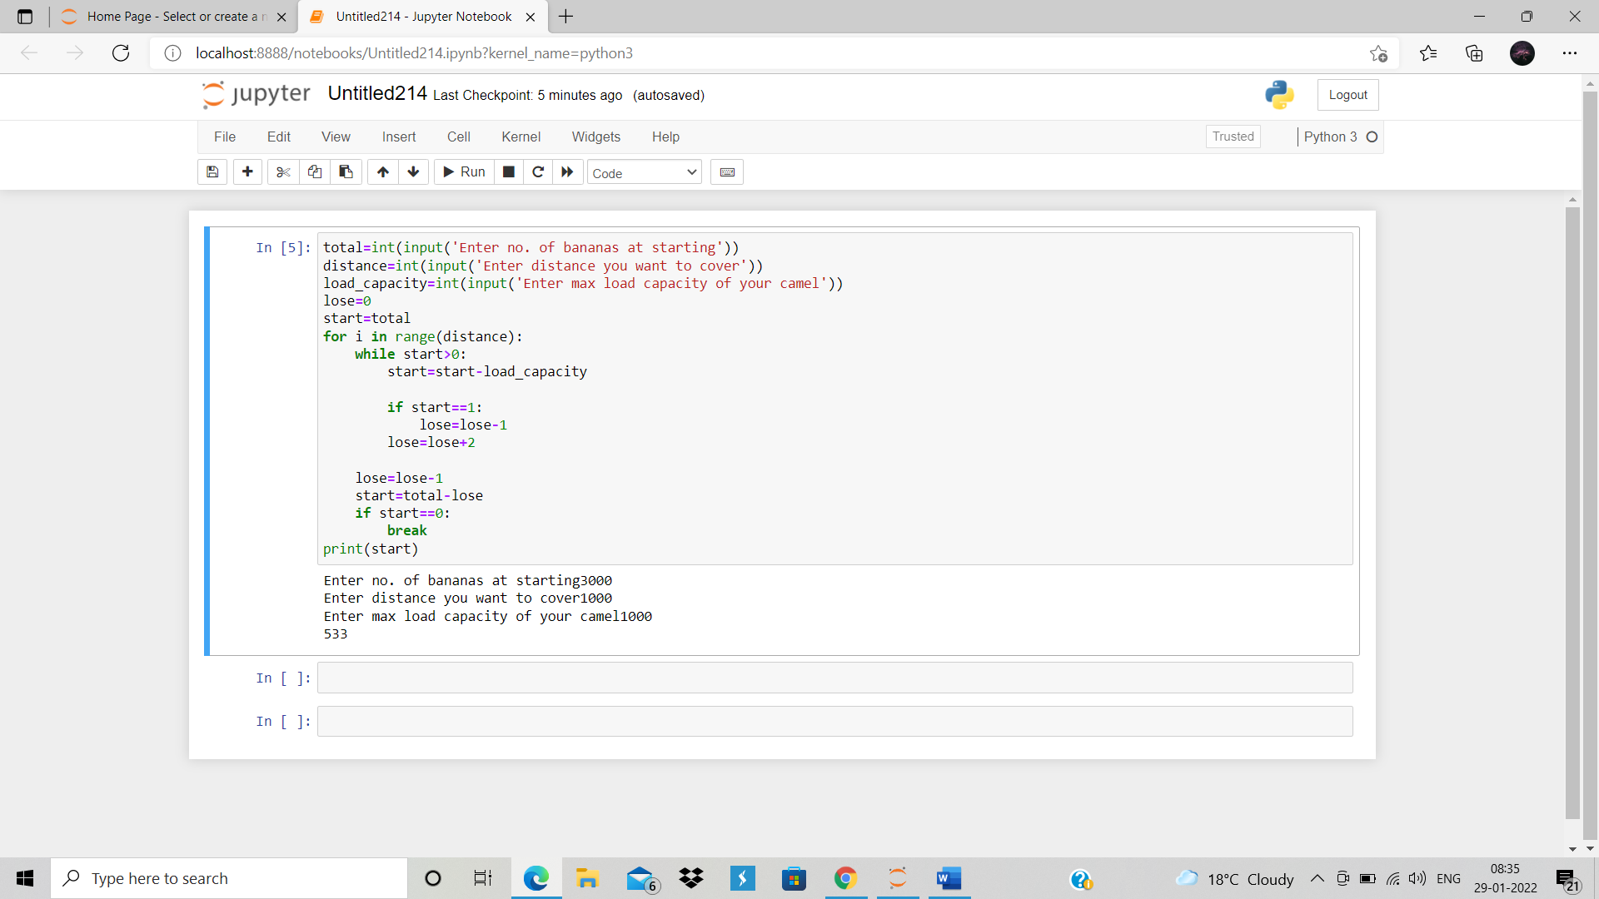

G. SRAVANI NEEHARIKA

(RA1911003010820)